Assessment Schedule – 2013

Chemistry: Demonstrate understanding of the properties of organic compounds (91391)
Evidence Statement
Q | Evidence | Achievement | Achievement with Merit | Achievement with Excellence
ONE  (a) | 3-hydroxy propanal / 3-hydroxyl propanal  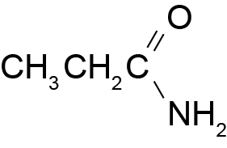  4-methyl pentan-2-one | - TWO correct – Names and / or structure.  OR  THREE correct but with errors in numbering. | - ALL THREE correct.
(b)(i) | 3-D structure drawn, eg:  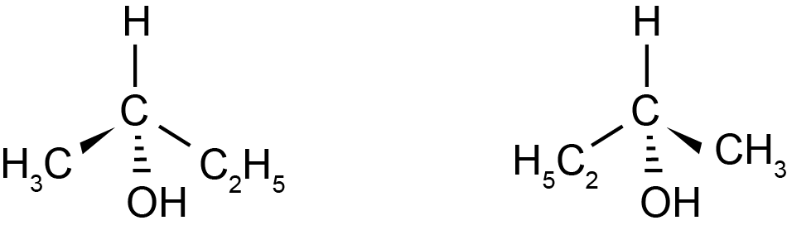  Any pair of enantiomers that are valid 3-D structures will be accepted. | - ONE isomer drawn correctly with 3D arrangements of groups around asymmetric carbon.  OR  In (b) (i), BOTH isomers drawn but an error in the way the groups are connected to asymmetric carbon. | - Correct 3D arrangements drawn, representing molecules that are enantiomers.
(ii) | - Enantiomers exist for atoms containing a carbon atom with 4 different groups attached / Non-optically active substances do not have any carbon with 4 different groups attached.  - Enantiomers rotate (plane) polarised light in opposite directions. | - ONE correct statement. | - TWO correct statements.
(c)(i)  (ii)  (iii) | 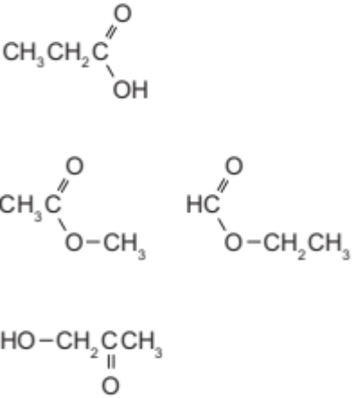 | - ONE correct.  OR  THREE compounds with correct functional groups. | - THREE correct.
(d) | 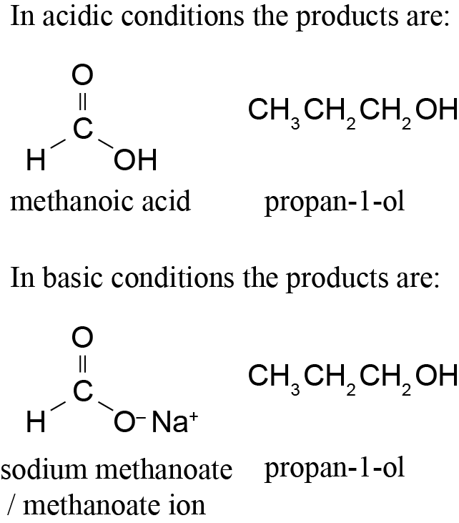  - The ester link is hydrolysed in both acid and basic conditions.  - Both produce an alcohol.  - Acidic hydrolysis produces an acid and basic hydrolysis produces a base or salt / following hydrolysis in sodium hydroxide, an acid-base reaction occurs to form the sodium salt and water. (No further reaction occurs in acid.) | - TWO correct products (name or formula).  - Identifies hydrolysis. | - TWO correct products (name and formula).  AND  Identifies hydrolysis. | - ALL products correct (name AND formula).  AND  acidic hydrolysis compared and contrasted against basic hydrolysis.

Not Achieved | NØ | No response; no relevant evidence.
Not Achieved | N1 | 1a
Not Achieved | N2 | 2a
Achievement | A3 | 4a
Achievement | A4 | 5a
Merit | M5 | 3m
Merit | M6 | 4m
Excellence | E7 | 1e and 2m
Excellence | E8 | 1e and 3m

Q | Evidence | Achievement | Achievement with Merit | Achievement with Excellence
TWO  (a)(i) | Reagent: NaBH₄ / LiAlH₄  Type of reaction – reduction / redox | - EITHER  Correct reagent used.  OR  Type of reaction. | - Three reagents or reactions correct.
(ii)  (iii) | Reagent: conc H₂SO₄ / conc H₃PO₄ / Al₂O₃  Type of reaction – elimination / dehydration / condensation  Explanation:  - An elimination reaction occurs because the molecule has changed from saturated to unsaturated / a (C=C) double bond forms.  - Because water is removed / H and OH have been removed (from adjacent C atoms).  - The but-2-ene is the major product / but-1-ene is the minor product.  - A mixture of products is formed, because the two carbons adjacent to the carbon-bearing OH have different numbers of H atoms attached / it is asymmetric.  (Zaitsev’s rule – the major product has the more substituted double bond) | - EITHER  Correct reagent used.  OR  Type of reaction.  - Elimination partially defined.  - Identifies but-2-ene as major product or but-1-ene as minor product. | - Elimination explained.  - Mixture of products explained. | Part (a) answered in full.
(b) | Aldehyde (Butanal) is obtained by distillation of butan-1-ol with acidified (potassium) dichromate / (acidified potassium) permanganate solution.  (Distillation) is used because the aldehyde has a lower boiling point (than butan-1-ol and the carboxylic acid formed) / to prevent it from being oxidised further.  (Both) reactions are oxidation–reduction because butan-1-ol has lost electrons/lost hydrogen/gained oxygen/oxidation number (of C) has increased.  Carboxylic acid (butanoic acid) is obtained by reacting a mixture of butan-1-ol with acidified potassium dichromate solution (under reflux conditions) until all of the reactant has been converted to butanoic acid.  Observations: orange Cr₂O₇^{2–} to green /, purple MnO₄– to colourless / aldehyde condensed in the condenser. | - One process identified.  - Identifies oxidation (or reduction) reaction.  - Reagent identified.  OR  One observation. | - A correct explanation of distillation.  - Type of reaction justified.  - One observation linked. | - Full discussion.

(c) | Add to water then test with blue litmus paper  The butan-1-ol will not react with water nor change the colour of the moistened litmus paper.  The butanoic acid will change the moistened blue litmus paper to red.  The butanoyl chloride will react violently with the water.  Carboxylic acids react with water to form hydronium ions / equation  Acyl chlorides react with water to form carboxylic acids and hydrogen chloride / equation | - ONE chemical identified.  - ONE chemical (word or symbol) equation. | - Devises a correct method with observations identifying all THREE substances. | - Correct method referenced to the structure of the organic compounds.

Not Achieved | NØ | No response; no relevant evidence.
Not Achieved | N1 | 1a
Not Achieved | N2 | 2a
Achievement | A3 | 4a
Achievement | A4 | 5a
Merit | M5 | 4m
Merit | M6 | 5m
Excellence | E7 | 1e and 2m
Excellence | E8 | 2e

Q | Evidence | Achievement | Achievement with Merit | Achievement with Excellence
THREE  (a)(i) | The three alcohols are (structural) isomers / they have the same molecular formula but different structural formula.  - Methyl propan-2-ol is a tertiary alcohol / structural formula.  - Butan-2-ol is a secondary alcohol / structural formula.  - Butan-1-ol is a primary alcohol / structural formula. | - Identifies that they are isomers.  - TWO alcohol types are correctly identified.  OR  Two correct structural formulae are drawn.  - Identifies ONE alcohol with partial explanation.  - Correctly links observations to species involved in one reaction. | - Isomers AND ALL types identified.  - Identifies TWO alcohols with minor omission (eg acidified or ‘conc’ missing). | - Identifies all three alcohols.
(ii) | - Butan-1-ol is oxidised using permanganate / acidified dichromate,  EITHER  forming an aldehyde which can be identified using Tollens’, silver mirror forms / Benedict’s or Fehling’s solution.  OR  forms brick red precipitate / forming a carboxylic acid, which can be identified turning (moist) blue litmus paper red.  - Butan-2-ol is oxidised to a ketone with permanganate / acidified dichromate, but this does not give a positive test using Tollens’ or Benedict’s.  - Methyl propan-2-ol does not react with oxidising agents, permanganate remains purple / dichromate remains orange.  Lucas test may be accepted with correct explanation.  (anhydrous) ZnCl₂ and conc HCl  Solution goes cloudy / layers form  Tertiary in seconds  Secondary in minutes  Primary in hours / no reaction. |  |  | - Identifies all three alcohols.
(b) | 1 SOCl₂  (Accept PCl₃, PCl₅ or conc HCl / ZnCl₂)  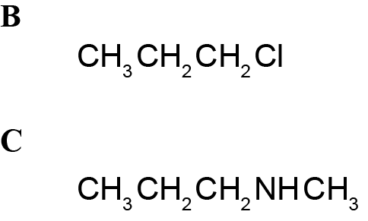 | - ONE correct | - ALL correct
(c) | Name: 3 methyl butanoyl chloride.  Products:  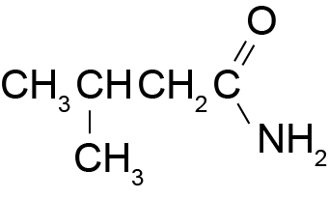  Hydrogen chloride / HCl / ammonium chloride / NH₄Cl | - ONE correct. | - ALL correct answers.
(d) | TWO correct structures drawn and amide linkages identified with circles.  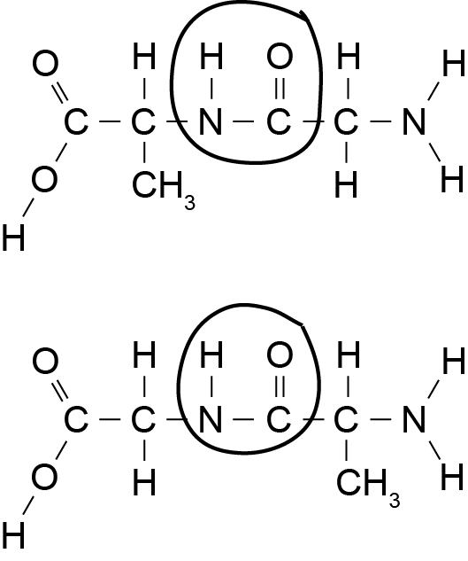 | - ONE correct dipeptide structure.  - Amide linkage correctly circled on ONE structure. | - ALL correct.

Not Achieved | NØ | No response; no relevant evidence.
Not Achieved | N1 | 2a
Not Achieved | N2 | 3a
Achievement | A3 | 4a
Achievement | A4 | 5a
Merit | M5 | 3m
Merit | M6 | 4m
Excellence | E7 | 1e and 2m
Excellence | E8 | 1e and 3m

Judgement Statement
 | Not Achieved | Achievement | Achievement with Merit | Achievement with Excellence
Score range | 0 – 7 | 8 – 12 | 13 – 18 | 19 – 24

